Hands-On Lab
Lab Manual
OGate Project On Eclipse

Contents
Mục lục
Lab Objective: 3
What do you need: 3
Exercise 1: Configure Environment Variable 4
Exercise 2: Configure Eclipse 7
Task 1: Configure Google Android SDK 7
Task 2: Configure Google App Engine SDK 8
Task 3: Configure Installed JREs 10
Exercise 3: Run OGate Project On Eclipse 13
Task 1: Import OGate Project 13
Task 2: Run OGate Project 16

Lab Objective:
The objective of this lab is to introduce you how to configure Windows and Eclipse to run OGate project.

What do you need:
- Java JDK has been installed on your system (windows)
- Eclipse has been customized for Open-Ones Group, download here.
- Android SDK for Windows v1.0, dowload here.
- Google Apps engine Java SDK for Windows 1.4.3, download here.

Exercise 1: Configure Environment Variable
- Right-click on the My Computer icon and click Propertise:
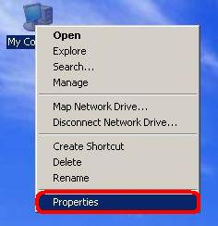
- Select Advanced tab then click Environment Variables button:
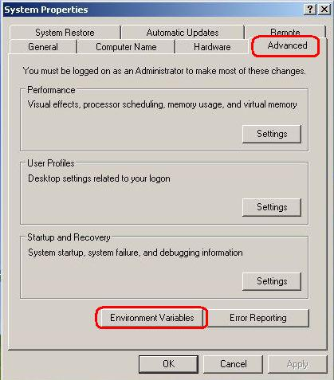

- On "User variables for Username" panel, click New button and do as the following picture:
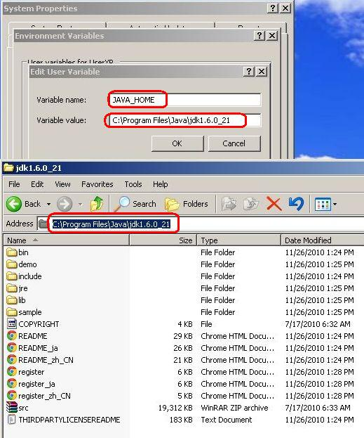

- On System variables panel, double-click on Path and append %JAVA_HOME%\bin; to Variable value then OK.
Make sure before %JAVA_HOME%\bin; have the ; character.
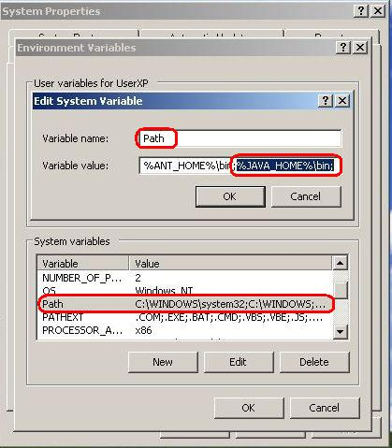

Exercise 2: Configure Eclipse

Task 1: Configure Google Android SDK
- On the menu of Eclipse, click Window and click Preferences:
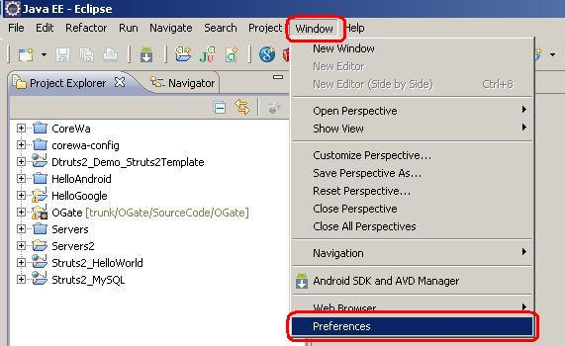
- Select Android on the left menu, then click Browse button to browse to android-sdk-windows folder and OK:
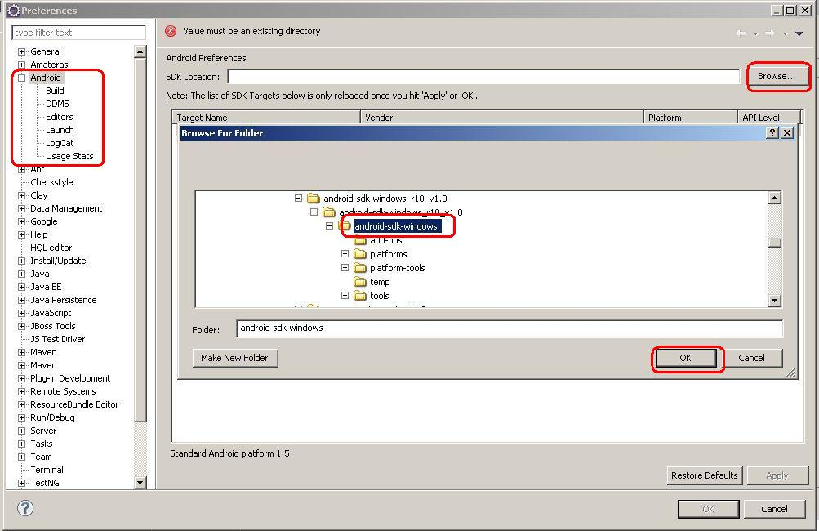
- Now, we have the value in SDK Location, click OK to finish:
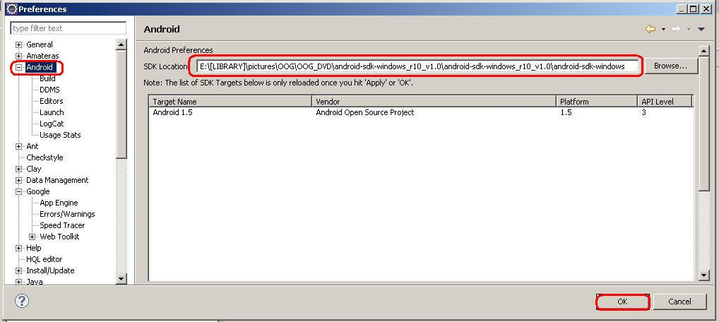

Task 2: Configure Google App Engine SDK
- On the menu of Eclipse click Window and click Preferences:

- Select Google on the left menu, then click Add button and Browse to appengine-java-sdk folder.
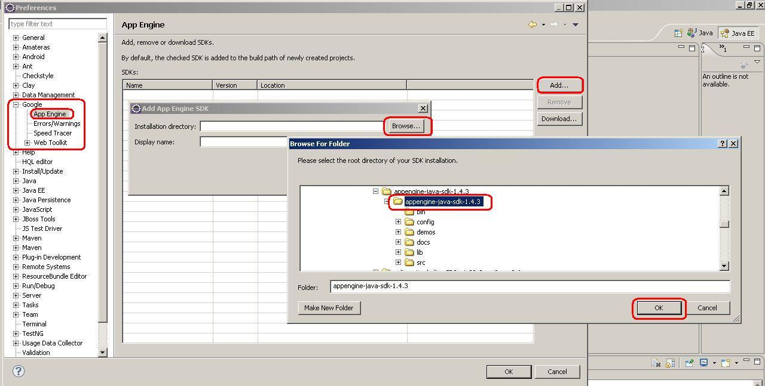
- Click OK to finish:
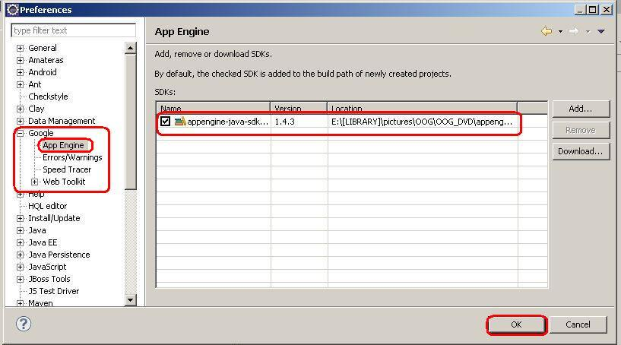

Task 3: Configure Installed JREs
- On the menu of Eclipse, click Window and Preferences:

- Select Java on the left menu then select Installed JREs, click Add button, choose Standard VM and Next:
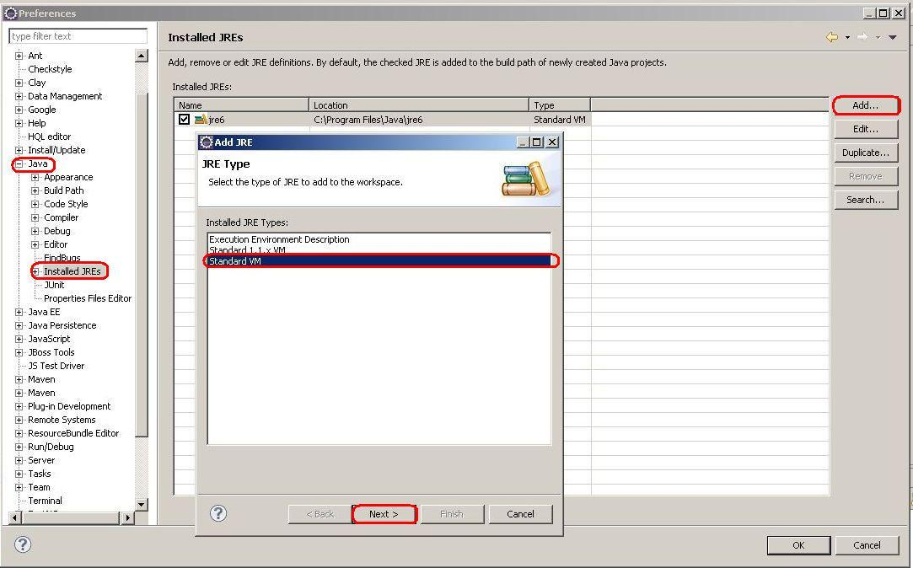

- Click Directory... then choose Java SDK folder and OK:
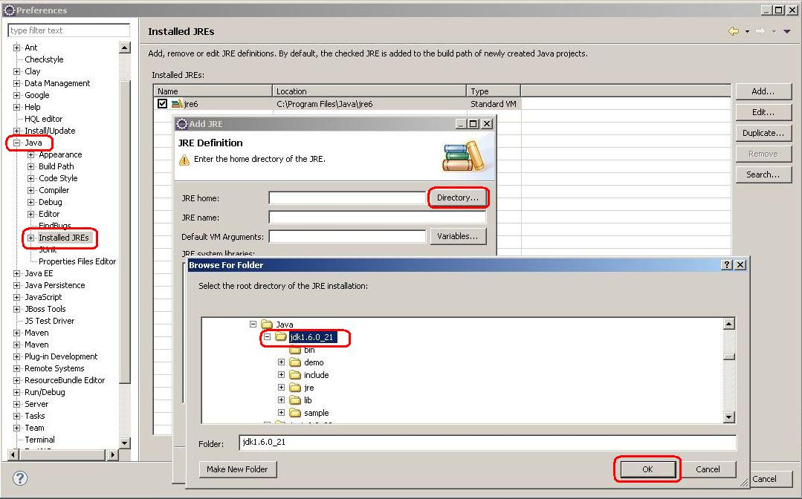

- Click Finish:
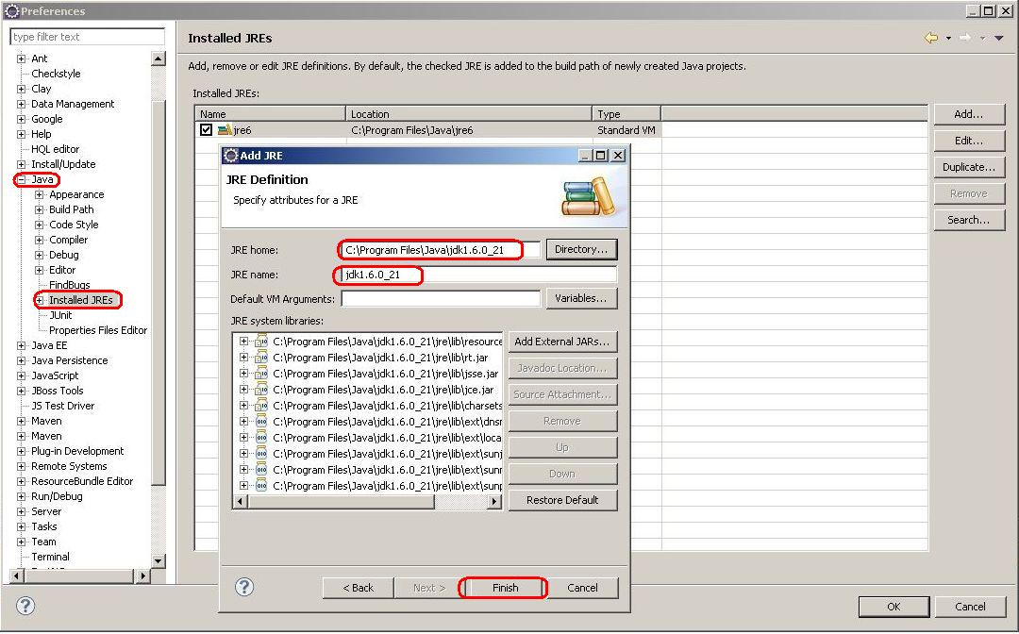

- To run OGate Project, make sure you checked jdk (not jre) then OK to finish:
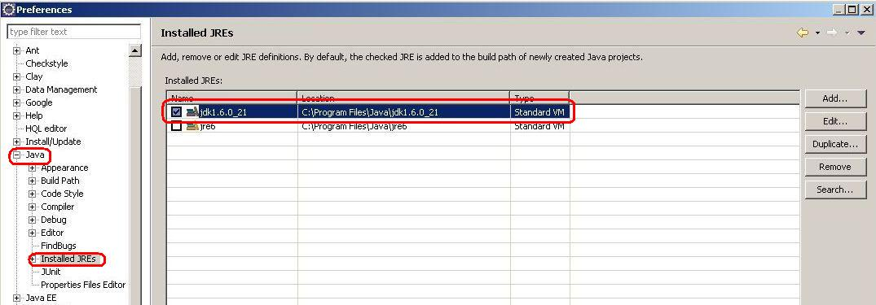

Exercise 3: Run OGate Project On Eclipse

Task 1: Import OGate Project
- On the menu of Eclipse, click File then Import:
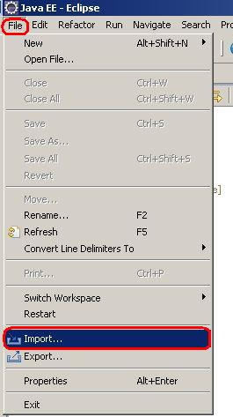

- Select Existing Projects into Workspace in Ganeral, then click Next:

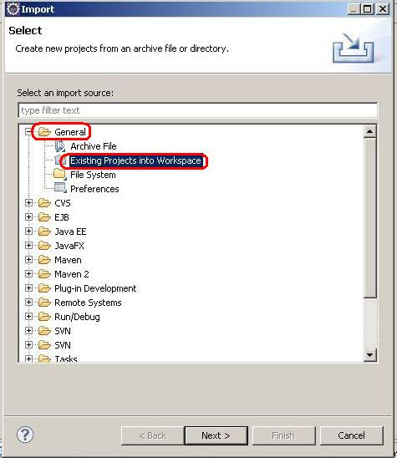

- Browse to OGate project source code and OK:

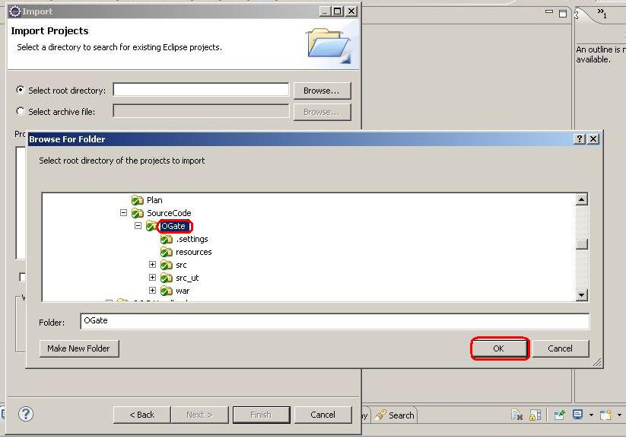
- We will have the result as the following picture then click Finish:
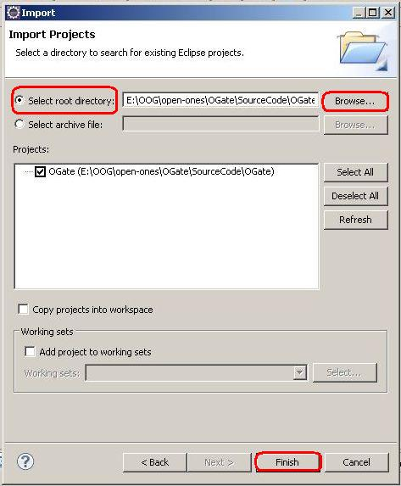

Task 2: Run OGate Project
- Right-click on the OGate project and click Refresh:
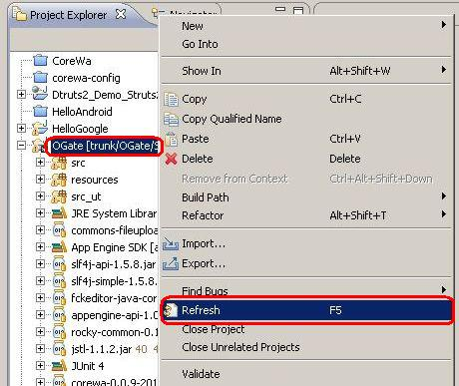
- On the menu of Eclipse, click Project then Clean... (make sure Build Automatically has been checked):
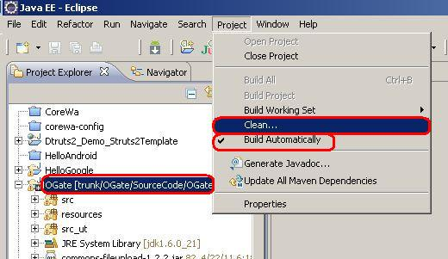

- OGate project have been checkek, click OK:
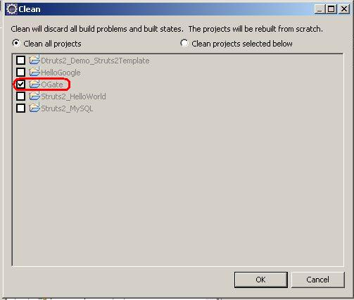

- Right-click on the OGate project\Run As\Web Application:
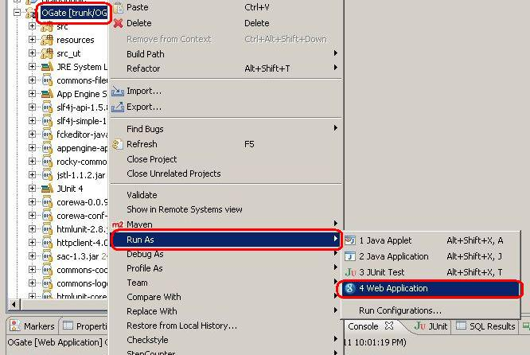
- After OGate have been deployed, in the console window, copy the text and paste into address bar of Internet Browse:
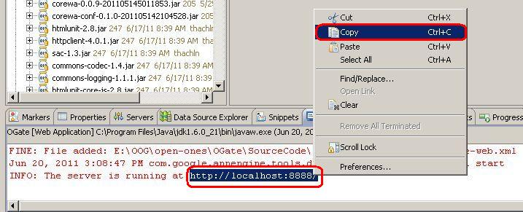

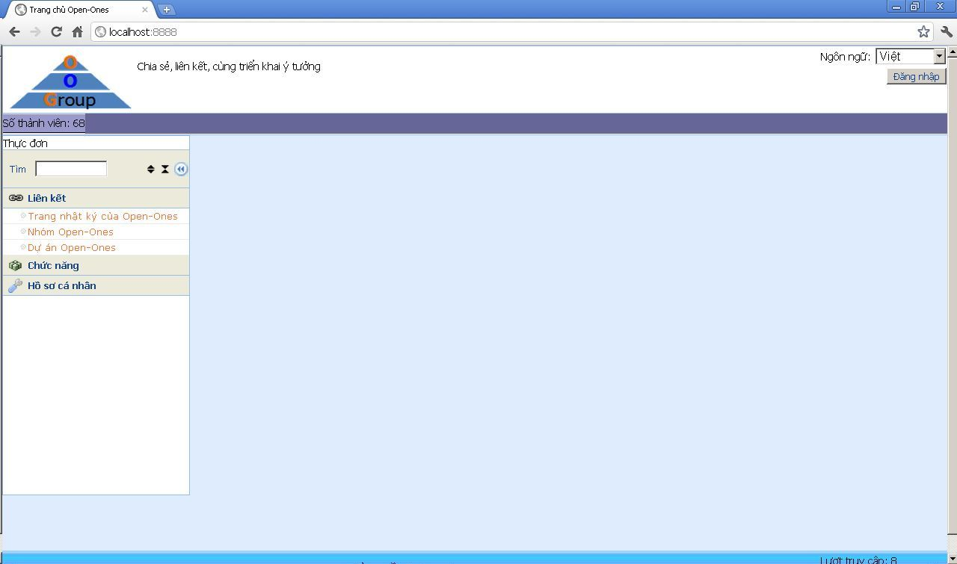
- Congratulate:

